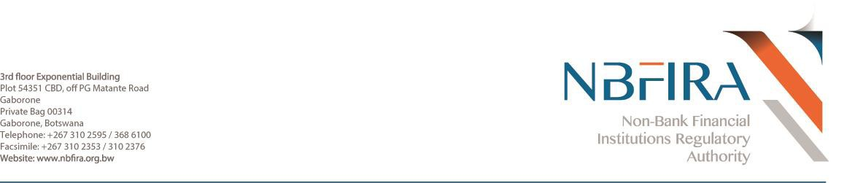

April 20, 2018

**NBFIRA 3/3/5-I (15)**

To: Principal Officers- Non-Bank Financial Institutions (“NBFIs”)

Dear Sir/Madam,

**ADDITION TO THE ISIL AND AL-QAIDA SANCTIONS LIST**

1. We refer to the captioned subject matter.

2. Botswana has an obligation to support international efforts to prevent, suppress and disrupt proliferation of weapons of mass destruction and the financing of terrorism.

3. In furtherance of the above, regulated entities are required to search their databases for any existence, assets, dealings or relationship with the listed entities from the United Nations Security Council (“UNSC”) sanctions lists and report any **positive matches**, **near matches** or **no matches** to the **Financial Intelligence Agency without delay**. Kindly note that all regulated entities are therefore required to immediately search their databases upon receipt of this circular. **To make these reporting arrangements, entities are kindly advised to contact FIA at: 3998402.**

4. Attached hereto a list of additions to the Isil an Al-Qaida sanctions list as of 29 March, 2018. The list comprises of a section on;

- Section B on entities and other groups

5. Kindly note that this list and any that have been disseminated before this one are in full force and effect until the UNSC advises otherwise. Regulated entities are therefore expected to monitor and be on high alert for any future dealings or relationships with the listed entities and/or individuals of all circulars that have been disseminated to date and are responsible to continuously and timeously familiarize themselves with updates made by the UNSC and the Financial Action Task Force (“FATF”) in their respective websites.

6. You are kindly advised to view the website below for a fully updated version of the list of individuals and entities subject to sanctions measures. Regulated entities are required to consult this website on a regular basis for any updates;

[**https://www.un.org/sc/suborg/en/sanctions/un-sc-consolidated-list.**](https://www.un.org/sc/suborg/en/sanctions/un-sc-consolidated-list.)

7. In addition, kindly view the FATF website at [**http://www.fatf-gafi.org/countries/#high-risk**](http://www.fatf-gafi.org/countries/#high-risk) for updates on high risk and non-co-operative jurisdictions. Regulated entities are required to apply enhanced due diligence to business relationships and transactions with individuals from high risk and non-co-operative jurisdictions.

8. Regulated entities that provide products or services to the listed individuals, entities and other groups as a result of failing to implement adequate screening measures not only commit an offence in accordance with section 9 (3) of the Financial Intelligence Act but also expose themselves to an extremely high risk of Terrorist Financing and/or advancing weapons proliferation objectives.

9. For any clarity on the above, kindly contact our respective departments at 310 2595 or 368 6100.

Yours faithfully

______________

Sriram Gade (Mr)

**Deputy CEO-Regulatory**